COMM 215: Business Statistics
Section EC
Winter 2020

_____________________________________________________________________________________
Data Analysis Project(8%)

Data file: housesales_data.xlsx
Report uploading Deadline: April 14, 2020, 23:59:59
_____________________________________________________________________________________

Description
The Analytics Division of your organizationis entrusted with a consulting contract for a city that plans to institute a policy on home sales transactions.As a member of the team, you have accessed a random sample oftransactions obtained for home sales between 2015 and 2018.The data file contains information on sales prices as it relates to various characteristics of the homes and surrounding property. Each line of the data set has an identification number and provides information on 6 other variables.

PPS sample with constraints on column values was taken from a bigger data set, (kc_house_data.csv) accessed from kaggle.com, cleaned and modified to meet the level of this course for a data analysis project.

The data set, HouseSales_data.xlsx,contains the following variables:

IDNO | Identification number
PRICE | Prediction targetPrice (dollars)
BEDROOMS | Bedrooms/House
BATHROOMS | Bathrooms/House
SQFT_LIVING | Square footage of the home
SQFT_LOT | Square footage of the lot
GRADE | Overall grade given to the housing unit (1 for lowest, …, 11 for the best)

Managerial Report

Use appropriate (applicable) methods of descriptive statistics, including tables and plots, to summarize the data (depending on the data type - quantitative continuous or discrete and qualitative or categorical). That is, prepare appropriate tables of descriptive statistics (mean, standard deviation, coefficient of variation, quartiles, IQR, correlations) and appropriate plots (histograms, dotplots, bar/pie charts, stem plots, boxplots, scatterplots) of the variables, overall and when appropriate, by categories.You are expected to produce displays that will allow you to describe the distribution in terms of symmetry, dispersion, and outlying observations.Present the summaries of statistical resultsthat will be beneficial in communicating to others. The results must be fully discussed and clearly explained in context addressing the issues.

Follow the guideline for preparing the project report. As part of the analysis, you are expected to address the following questions:

1.
a. Prepare tables of descriptive statistics of price, square footage of homes and square footage of lots. Discuss.

Table 1.1

Price of House ($) | Frequency | Relative Frequency
100k-200k | 20 | 0.0400
200k-300k | 92 | 0.1840
300k-400k | 119 | 0.2380
400k-500k | 93 | 0.1860
500k-600k | 68 | 0.1360
600k-700k | 43 | 0.0860
700k-800k | 28 | 0.0560
800k-900k | 24 | 0.0480
900k-1M | 13 | 0.0260
Total | 500 | 1

Description of Price | Data of Price
MEAN | $455,982.94
STANDARD DEVIATION | $190,264.35
COEFFICIENT OF VARIATION | 0.4173
MIN | $125,000.00
QUARTILE 1 | $310,250.00
MEDIAN | $414,625.00
QUARTILE 3 | $569,337.50
MAX | $995,000.00
IQR | $259,087.50

Square Footage of House | Frequency | Relative Frequency
500-1000 | 33 | 0.0660
1000-1500 | 132 | 0.2640
1500-2000 | 141 | 0.2820
2000-2500 | 112 | 0.2240
2500-3000 | 39 | 0.0780
3000-3500 | 27 | 0.0540
3500-4000 | 12 | 0.0240
4000-4500 | 3 | 0.0060
4500-5000 | 0 | 0.0000
5000-5500 | 1 | 0.0020
 | 500 | 1

Table 2.2

Description of SQFT of House | Data (SQFT)
MEAN | 1878.56
STANDARD DEVIATION | 714.45
COEFFICIENT OF VARIATION | 0.3803
MIN | 590
QUARTILE 1 | 1350
MEDIAN | 1770
QUARTILE 3 | 2267.5
MAX | 5440
IQR | 917.5

Square Footage of Lot | Frequency | Relative Frequency
0-50,000 | 476 | 0.9520
50,000-100,000 | 10 | 0.0200
100,000-150,000 | 2 | 0.0040
150,000-200,000 | 0 | 0.0000
200,000-250,000 | 10 | 0.0200
250,000-300,000 | 0 | 0.0000
300,000-350,000 | 0 | 0.0000
350,000-400,000 | 1 | 0.0020
400,000-450,000 | 1 | 0.0020
 | 500 | 1

Square Footage of Lot | Frequency | Relative Frequency
0-5000 | 132 | 0.2773
5000-10,000 | 232 | 0.4874
10,000-15,000 | 67 | 0.1408
15,000-20,000 | 16 | 0.0336
20,000-25,000 | 6 | 0.0126
25,000-30,000 | 3 | 0.0063
30,000-35,000 | 8 | 0.0168
35,000-40,000 | 6 | 0.0126
40,000-45,000 | 4 | 0.0084
45,000-50,000 | 2 | 0.0042
 | 476 | 1

Description of SQFT. of Lot | Data (SQFT)
MEAN | 16587.82
STANDARD DEVIATION | 42012.93
COEFFICIENT OF VARIATION | 2.53
MIN | 638
QUARTILE 1 | 4804.5
MEDIAN | 7467.5
QUARTILE 3 | 10279.25
MAX | 443440
IQR | 5474.75

b. Prepare tables of descriptive statistics for price and square footage of the homes and square footage of lots,by categories of bedrooms, bathrooms, and grade. Discuss.

 |  | Price of Houses, by Bedrooms, Bathrooms & Grade
 |  | Mean | Std. Dev. | Min | Q1 | MEDIAN | Q3 | MAX
BEDROOMS | 2 | $396,596.11 | $162,448.93 | $155,000.00 | $265,000.00 | $375,000.00 | $465,000.00 | $985,000.00
BEDROOMS | 3 | $435,360.06 | $182,138.61 | $125,000.00 | $298,000.00 | $396,475.00 | $554,250.00 | $954,500.00
BEDROOMS | 4 | $513,569.37 | $199,900.15 | $179,000.00 | $352,000.00 | $475,000.00 | $660,000.00 | $995,000.00
BATHROOMS | 1 | $385,150.82 | $150,713.38 | $125,000.00 | $271,500.00 | $360,000.00 | $460,000.00 | $913,000.00
BATHROOMS | 2 | $504,608.68 | $197,806.03 | $158,000.00 | $339,975.00 | $465,950.00 | $657,000.00 | $995,000.00
BATHROOMS | 3 | $640,024.54 | $272,934.46 | $248,000.00 | $527,125.00 | $650,500.00 | $773,750.00 | $950,000.00
GRADE | 5 | $306,504.25 | $180,778.42 | $155,000.00 | $189,250.00 | $229,750.00 | $454,400.50 | $658,000.00
GRADE | 6 | $306,842.59 | $128,600.83 | $125,000.00 | $218,925.00 | $280,000.00 | $364,250.00 | $780,000.00
GRADE | 7 | $396,276.25 | $144,855.79 | $156,000.00 | $285,000.00 | $368,975.00 | $465,712.50 | $985,000.00
GRADE | 8 | $502,039.93 | $184,821.11 | $195,000.00 | $379,925.00 | $470,000.00 | $609,000.00 | $954,500.00
GRADE | 9 | $686,343.93 | $150,133.29 | $330,000.00 | $585,000.00 | $689,000.00 | $780,000.00 | $995,000.00
GRADE | 10 | $747,600.00 | $172,431.11 | $486,000.00 | $555,750.00 | $823,000.00 | $896,500.00 | $912,000.00

 |  | Square Footage of Houses, by Bedrooms, Bathrooms & Grade
 |  | Mean | Std. Dev. | Min | Q1 | MEDIAN | Q3 | MAX
BEDROOMS | 2 | 1232.44 | 444.27 | 590 | 920 | 1160 | 1430 | 2910
BEDROOMS | 3 | 1740.30 | 554.62 | 890 | 1347.50 | 1670 | 2052.5 | 3870
BEDROOMS | 4 | 2379.19 | 694.95 | 1020 | 1930 | 2300 | 2700 | 5440
BATHROOMS | 1 | 1453.10 | 460.14 | 590 | 1100 | 1410 | 1760 | 3390
BATHROOMS | 2 | 2192.15 | 643.01 | 1010 | 1735 | 2120 | 2495 | 5440
BATHROOMS | 3 | 2784.62 | 874.89 | 1290 | 2082.50 | 2955 | 3610 | 4210
GRADE | 5 | 995.38 | 205.29 | 730 | 852.25 | 985 | 1070 | 1420
GRADE | 6 | 1263.07 | 429.59 | 590 | 975 | 1135 | 1495 | 2380
GRADE | 7 | 1615.24 | 451.36 | 750 | 1280 | 1580 | 1912.5 | 3390
GRADE | 8 | 2119.43 | 543.07 | 1030 | 1770 | 2080 | 2420 | 3760
GRADE | 9 | 2808.84 | 737.43 | 1100 | 2340 | 2800 | 3270 | 5440
GRADE | 10 | 3505.10 | 458.99 | 2500 | 3296.25 | 3590 | 3810 | 4090

 |  | Square Footage of Lots, by Bedrooms, Bathrooms & Grade
 |  | Mean | Std. Dev. | Min | Q1 | MEDIAN | Q3 | MAX
BEDROOMS | 2 | 12565.68 | 31670.26 | 638 | 3128 | 4980 | 7658 | 223898
BEDROOMS | 3 | 16507.56 | 39681.65 | 932 | 5142.50 | 8211 | 10628.5 | 387684
BEDROOMS | 4 | 18563.34 | 49020.58 | 745 | 5427 | 7350 | 11325 | 443440
BATHROOMS | 1 | 12921.35 | 27578.67 | 638 | 5030 | 7455 | 9909 | 223898
BATHROOMS | 2 | 18891.33 | 46083.98 | 745 | 4512 | 7658 | 11228 | 387684
BATHROOMS | 3 | 28093.31 | 86434.72 | 1071 | 4000 | 5814.5 | 12176 | 443440
GRADE | 5 | 38541.25 | 51737.46 | 2400 | 4795.50 | 10477 | 76757.25 | 143947
GRADE | 6 | 19506.30 | 43878.69 | 3128 | 5687.50 | 7347 | 9460.5 | 223898
GRADE | 7 | 9478.97 | 15978.27 | 745 | 4416.50 | 7212.5 | 9186 | 215622
GRADE | 8 | 15060.89 | 49249.34 | 932 | 4245.50 | 7333 | 10354 | 443440
GRADE | 9 | 37863.73 | 71426.32 | 638 | 6222 | 9692 | 23786 | 247421
GRADE | 10 | 52703.10 | 59302.83 | 11225 | 13778 | 34627 | 69425.25 | 206474

c. Prepare appropriate displays (bar-/pie- charts, histograms, dotplots, boxplots) comparisons, for price and square footage of the home by bedrooms, by bathrooms and by grade.

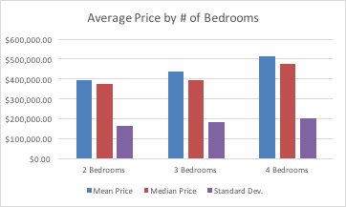
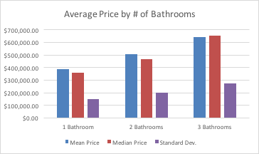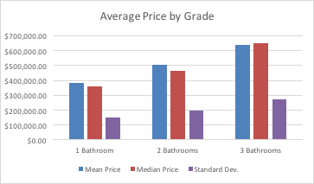

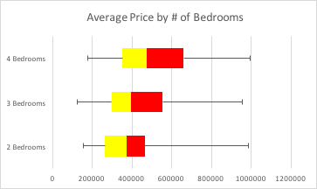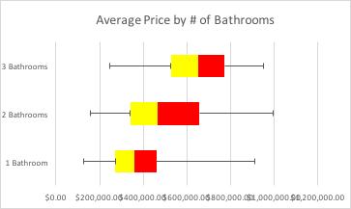
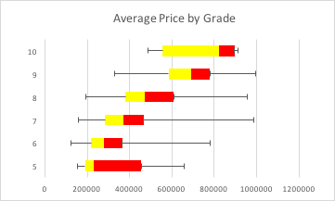

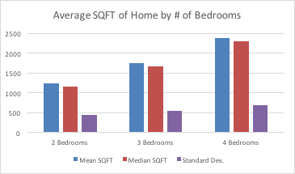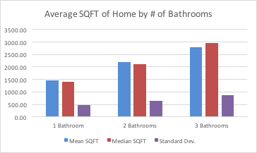
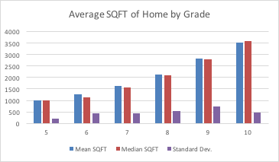

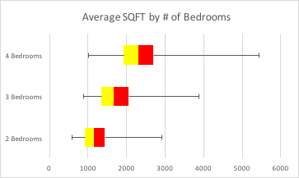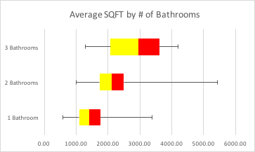

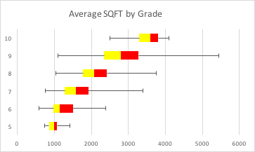

d. Do the plots suggest differences in terms of spread of the data and outlying values? Discuss.

e. Prepare contingency tables by categories of bedrooms vs bathrooms; bedroom vs grade; bathrooms vs grade, and test for the independence of the row and column categories. Discuss.

B  E  D  R  O  O  M  S | BATHROOMS
B  E  D  R  O  O  M  S |  |  | 1 | 2 | 3 | Total/1
B  E  D  R  O  O  M  S | 2 | Frequency | 64 | 15 | 0 | 0.158
B  E  D  R  O  O  M  S | 2 | Expected | 36.81 | 38.08 | 4.11
B  E  D  R  O  O  M  S | 2 |  | 20.08 | 13.99 | 4.11
B  E  D  R  O  O  M  S | 3 | Frequency | 122 | 116 | 12 | 0.5
B  E  D  R  O  O  M  S | 3 | Expected | 116.50 | 120.50 | 13.00
B  E  D  R  O  O  M  S | 3 |  | 0.260 | 0.168 | 0.077
B  E  D  R  O  O  M  S | 4 | Frequency | 47 | 110 | 14 | 0.342
B  E  D  R  O  O  M  S | 4 | Expected | 79.686 | 82.422 | 8.892
B  E  D  R  O  O  M  S | 4 |  | 13.41 | 9.23 | 2.93
B  E  D  R  O  O  M  S | Total/1 |  | 0.466 | 0.482 | 0.052 | 1

Chi Squared = 64.2446
D.F. = 4
Null Hypothesis (H₀): There is no correlation between the number of bedrooms and the number of bathrooms.
Alternative Hypothesis (H𝛼): There is a correlation between the number of bedrooms and the number of bathrooms in a house.
Significance Level (𝞪) = 5%
Critical Chi-Square Value = 9.49

Reject the null hypothesis, therefore there is a correlation between the number of bedrooms and the number of bathrooms in a house.

B  E  D  R  O  O  M  S | GRADE
B  E  D  R  O  O  M  S |  |  | 5 | 6 | 7 | 8 | 9 | 10 | Total/1
B  E  D  R  O  O  M  S | 2 | Frequency | 6 | 17 | 42 | 12 | 2 | 0 | 0.158
B  E  D  R  O  O  M  S | 2 | Expected | 1.26 | 8.53 | 36.66 | 22.278 | 8.69 | 1.58
B  E  D  R  O  O  M  S | 2 |  | 17.75 | 8.40 | 0.78 | 4.74 | 5.15 | 1.58
B  E  D  R  O  O  M  S | 3 | Frequency | 1 | 27 | 125 | 72 | 23 | 2 | 0.5
B  E  D  R  O  O  M  S | 3 | Expected | 4.00 | 27.00 | 116.00 | 70.5 | 27.5 | 5
B  E  D  R  O  O  M  S | 3 |  | 2.25 | 0.00 | 0.70 | 0.03 | 0.74 | 1.80
B  E  D  R  O  O  M  S | 4 | Frequency | 1 | 10 | 65 | 57 | 30 | 8 | 0.342
B  E  D  R  O  O  M  S | 4 | Expected | 2.736 | 18.468 | 79.344 | 48.222 | 18.81 | 3.42
B  E  D  R  O  O  M  S | 4 |  | 1.10 | 3.88 | 2.59 | 1.60 | 6.66 | 6.13
B  E  D  R  O  O  M  S | Total/1 |  | 0.016 | 0.108 | 0.464 | 0.282 | 0.11 | 0.02 | 1

Chi Squared = 65.8829
d.f. = 10
Null Hypothesis (H₀): There is no correlation between the number of bedrooms and the grade of a house.
Alternative Hypothesis (H𝛼): There is a correlation between the number of bedrooms and the grade of a house.
Significance Level (𝞪) = 5%
Critical Chi-Square Value = 18.31

Reject the null hypothesis, therefore there is a correlation between the number of bedrooms and the grade of a house.

B  A  T  H  R  O  O  M  S | GRADE
B  A  T  H  R  O  O  M  S |  |  | 5 | 6 | 7 | 8 | 9 | 10 | Total/1
B  A  T  H  R  O  O  M  S | 1 | Frequency | 8 | 47 | 141 | 36 | 1 | 0 | 0.466
B  A  T  H  R  O  O  M  S | 1 | Expected | 3.73 | 25.16 | 108.11 | 65.706 | 25.63 | 4.66
B  A  T  H  R  O  O  M  S | 1 |  | 4.90 | 18.95 | 10.00 | 13.43 | 23.67 | 4.66
B  A  T  H  R  O  O  M  S | 2 | Frequency | 0 | 7 | 86 | 94 | 45 | 9 | 0.482
B  A  T  H  R  O  O  M  S | 2 | Expected | 3.86 | 26.03 | 111.82 | 67.962 | 26.51 | 4.82
B  A  T  H  R  O  O  M  S | 2 |  | 3.86 | 13.91 | 5.96 | 9.98 | 12.90 | 3.62
B  A  T  H  R  O  O  M  S | 3 | Frequency | 0 | 0 | 5 | 11 | 9 | 1 | 0.052
B  A  T  H  R  O  O  M  S | 3 | Expected | 0.416 | 2.808 | 12.064 | 7.332 | 2.86 | 0.52
B  A  T  H  R  O  O  M  S | 3 |  | 0.42 | 2.81 | 4.14 | 1.84 | 13.18 | 0.44
B  A  T  H  R  O  O  M  S | Total/1 |  | 0.016 | 0.108 | 0.464 | 0.282 | 0.11 | 0.02 | 1

Chi Squared = 148.6547
d.f. = 10
Null Hypothesis (H₀): There is no correlation between the number of bathrooms and the grade of a house.
Alternative Hypothesis (H𝛼): There is a correlation between the number of bathrooms and the grade of a house.
Significance Level (𝞪) = 5%
Critical Chi-Square Value = 18.31

Reject the null hypothesis, therefore there is a correlation between the number of bathrooms and the number of bathrooms.

f. Provide 95% confidence intervals for mean price and square footage of homes, overall and by bedrooms, by bathrooms, and by grade. Discuss.

 |  | 95% Confidence Interval
 | Circumstance | 95% Confidence Level | Low Limit | High Limit
P  R  I  C  E | Overall | $16,717.65 | $439,265.29 | $472,700.59
P  R  I  C  E | 2 Bedroom | $36,386.58 | $360,209.54 | $432,982.69
P  R  I  C  E | 3 Bedrooms | $22,688.00 | $412,672.07 | $458,048.06
P  R  I  C  E | 4 Bedrooms | $30,176.29 | $483,393.08 | $543,745.66
P  R  I  C  E | 1 Bathroom | $19,453.31 | $365,697.51 | $404,604.12
P  R  I  C  E | 2 Bathrooms | $25,100.05 | $479,508.63 | $529,708.74
P  R  I  C  E | 3 Bathrooms | $71,539.19 | $568,485.35 | $711,563.73
P  R  I  C  E | Grade = 5 | $151,134.54 | $155,369.71 | $457,638.79
P  R  I  C  E | Grade = 6 | $35,101.27 | $271,741.32 | $341,943.86
P  R  I  C  E | Grade = 7 | $18,737.92 | $377,538.34 | $415,014.17
P  R  I  C  E | Grade = 8 | $30,772.34 | $471,267.59 | $532,812.27
P  R  I  C  E | Grade = 9 | $40,586.71 | $645,757.21 | $726,930.64
P  R  I  C  E | Grade = 10 | $123,349.79 | $624,250.21 | $870,949.79

 |  | 95% Confidence Interval
 | Circumstance | 95% Confidence Level | Low Limit | High Limit
S  Q  U  A  R  E  F  E  E  T | Overall | 62.78 | 1815.78 | 1941.34
S  Q  U  A  R  E  F  E  E  T | 2 Bedroom | 99.51 | 1132.93 | 1331.95
S  Q  U  A  R  E  F  E  E  T | 3 Bedrooms | 69.09 | 1671.21 | 1809.39
S  Q  U  A  R  E  F  E  E  T | 4 Bedrooms | 104.91 | 2274.29 | 2484.10
S  Q  U  A  R  E  F  E  E  T | 1 Bathroom | 59.39 | 1393.71 | 1512.50
S  Q  U  A  R  E  F  E  E  T | 2 Bathrooms | 81.59 | 2110.55 | 2273.74
S  Q  U  A  R  E  F  E  E  T | 3 Bathrooms | 353.37 | 2431.24 | 3137.99
S  Q  U  A  R  E  F  E  E  T | Grade = 5 | 171.63 | 823.75 | 1167.00
S  Q  U  A  R  E  F  E  E  T | Grade = 6 | 117.26 | 1145.82 | 1380.33
S  Q  U  A  R  E  F  E  E  T | Grade = 7 | 58.39 | 1556.85 | 1673.62
S  Q  U  A  R  E  F  E  E  T | Grade = 8 | 90.42 | 2029.00 | 2209.85
S  Q  U  A  R  E  F  E  E  T | Grade = 9 | 199.36 | 2609.48 | 3008.19
S  Q  U  A  R  E  F  E  E  T | Grade = 10 | 328.35 | 3176.75 | 3833.45

g. Prepare scatterplots of sales price on square footage of homes,overall and by categories of bedrooms, bathrooms, and grade. Do the plots suggest relationships between the variables? Discuss the nature of the relationships.

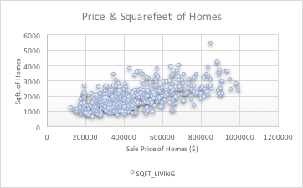

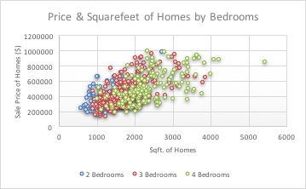

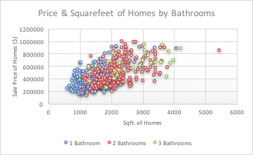

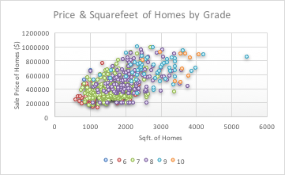

h. Prepare correlations of price and square footage of homes, overall and by categories of bedrooms, bathrooms, and grade. Test for significances of the relationships and interpret your results.

Price & Square Footage
R Square | 0.3594
Intercept | 156047.48
Square Feet (x variable) | 159.66

Price & Square Footage by Bedrooms
2 Bedrooms | R Square | 0.3408
2 Bedrooms | Intercept | 133505.68
2 Bedrooms | Square Feet (x variable) | 213.47
3 Bedrooms | R Square | 0.3600
3 Bedrooms | Intercept | 92437.55
3 Bedrooms | Square Feet (x variable) | 197.05
4 Bedrooms | R Square | 0.3323
4 Bedrooms | Intercept | 119047.15
4 Bedrooms | Square Feet (x variable) | 165.82

Price & Square Footage by Bathrooms
1 Bathroom | R Square | 0.2067
1 Bathroom | Intercept | 168785.84
1 Bathroom | Square Feet (x variable) | 148.90
2 Bathrooms | R Square | 0.2828
2 Bathrooms | Intercept | 146001.64
2 Bathrooms | Square Feet (x variable) | 163.5873
3 Bathrooms | R Square | 0.2905
3 Bathrooms | Intercept | 336165.35
3 Bathrooms | Square Feet (x variable) | 109.12

Price & Square Footage by Grade
5 | R Square | 0.0192
5 | Intercept | 428109.84
5 | Square Feet (x variable) | -122.17
6 | R Square | 0.0665
6 | Intercept | 209356.38
6 | Square Feet (x variable) | 77.18
7 | R Square | 0.1082
7 | Intercept | 225759.45
7 | Square Feet (x variable) | 105.57
8 | R Square | 0.1547
8 | Intercept | 218336.93
8 | Square Feet (x variable) | 133.86
9 | R Square | 0.0842
9 | Intercept | 520381.44
9 | Square Feet (x variable) | 59.09
10 | R Square | 0.0038
10 | Intercept | 828408.90
10 | Square Feet (x variable) | -23.05

2 Use the least-squares procedure to fit a prediction equation for price based on square footage of homes, and square footage of lots. Test hypotheses, construct confidence intervals for the significant relationships and interpret all your findings.

SUMMARY OUTPUT
Regression Statistics
Multiple R | 0.599536
R Square | 0.359444
Adjusted R Square | 0.358157
Standard Error | 152430.4
Observations | 500
ANOVA
 | df | SS | MS | F | Significance F
Regression | 1 | 6.49E+12 | 6.49E+12 | 279.4491 | 4.0415E-50
Residual | 498 | 1.16E+13 | 2.32E+10
Total | 499 | 1.81E+13
 | Coefficients | Standard Error | t Stat | P-value | Lower 95% | Upper 95%
Intercept | 156047.5 | 19193.59 | 8.130189 | 3.43E-15 | 118337.091 | 193757.9
SQFT_LIVING | 159.6624 | 9.551056 | 16.71673 | 4.04E-50 | 140.897105 | 178.4278

The regression equation is Y =156047.5 + 159.66 X, where X is Square footage of homes and Y is Price.
Test Hypothesis:
H_{o}:β₁=0
H_{a}:β₁≠0
α=0.05
This is F-test using regression.
From above table, we get F-Statistic=279.45 and P-value=0.000
Since 0.000 < 0.05, it falls in the rejection region. Therefore, reject the null hypothesis and conclude that there is significant evidence of relationship between Price and Square footage of homes.
We can be 95% confident that for each increase of $1 in price the increase in Square footage of homes is between 140.897 and 178.428. Therefore, the confidence interval does not include 0; there is good evidence that Price and Square footage of homes are related.

SUMMARY OUTPUT
Regression Statistics
Multiple R | 0.13585
R Square | 0.018455
Adjusted R Square | 0.016484
Standard Error | 188689.7
Observations | 500
ANOVA
 | df | SS | MS | F | Significance F
Regression | 1 | 3.33E+11 | 3.33E+11 | 9.363491 | 0.00233287
Residual | 498 | 1.77E+13 | 3.56E+10
Total | 499 | 1.81E+13
 | Coefficients | Standard Error | t Stat | P-value | Lower 95% | Upper 95%
Intercept | 445777.7 | 9073.601 | 49.12909 | 4.3E-193 | 427950.448 | 463605
SQFT_LOT | 0.615225 | 0.201055 | 3.059982 | 0.002333 | 0.22020415 | 1.010245

The regression equation is Y =445777.7 + 0.62 X, where X is square footage of lots and Y is Price.
Test Hypothesis:
H_{o}:β₁=0
H_{a}:β₁≠0
α=0.05
This is F-test using regression.
From above table, we get F-Statistic=9.363 and P-value=0.002
Since 0.002 < 0.05, it falls in the rejection region. Therefore, reject the null hypothesis and conclude that there is significant evidence of relationship between Price and Square footage of lots.
We can be 95% confident that for each increase of $1 in price the increase in square footage of lots is between 0.220 and 1.010. Therefore, the confidence interval does not include 0, there is good evidence that Price and square footage of lots are related.

- Do your results suggest any recommendations for learning about and/or implementing policy on home sales transactions? Write a business report based on your results from items in 1 and 2 above, strictly following the guideline.

In this data analysis assignment, we found out that we were able to gather a lot of information about our participants in the survey through a number of charts and graphs representing relative frequencies. We also managed to determine the distribution of the sample population by constructing box and whisker plots and focusing on measures of central tendency. We have also determined, through contingency tables and a chi-squared test, that there are significant relationships between the variables we have chosen. In each case we have reject the null hypothesis. We believe that there are significant relationships between certain variables in this survey because most of them are independent and everyone has different ideas. Furthermore, we analyzed the House sales Associations with their price based on square footage of homes, and square footage of lots. We conclude that there is weak positive relationship between the variables. For future studies, we recommend a bigger sample size to reduce sample errors and to better represent the population.

Remark: Minitab software, accessible to section EC students, has all the tools you need and more to work with data easily and complete your assignment on time.

